**Assignment -9**

**Session 1**

Implementation of:

apply with images with some points in paint

1. Linked lists:

There is 4 type of linked lists

Singly Linked list

Doubly linked list

Circular linked list

Circular Doubly linked list

1. Singly linked lists

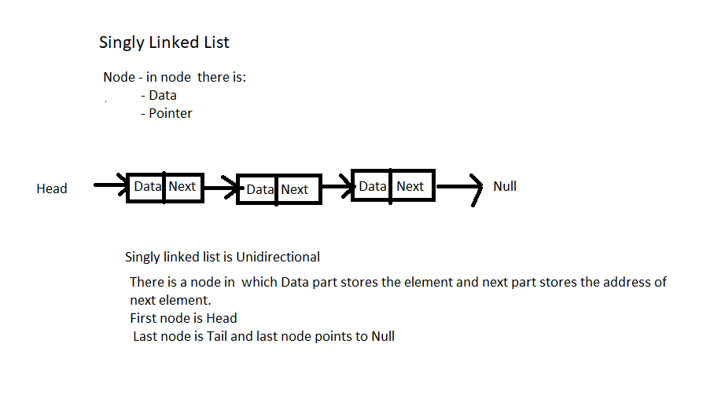

1. Doubly linked lists

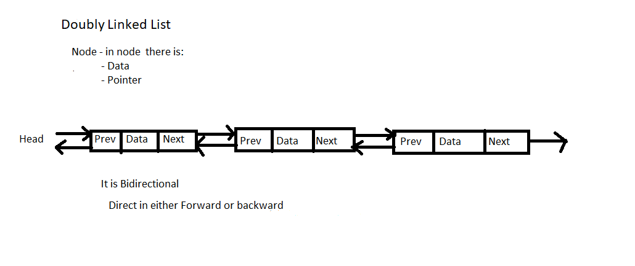

1. Circular linked lists

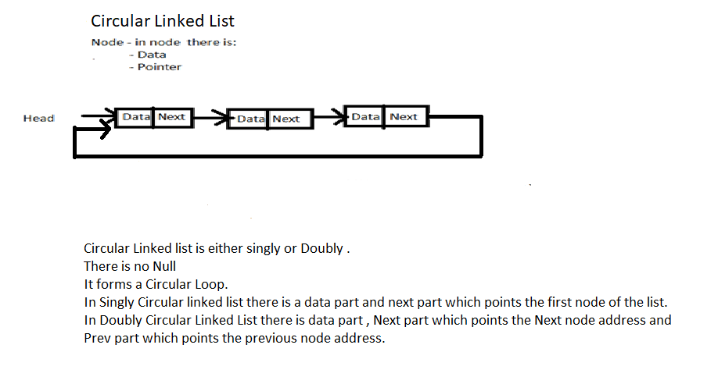

1. Stacks and Queues

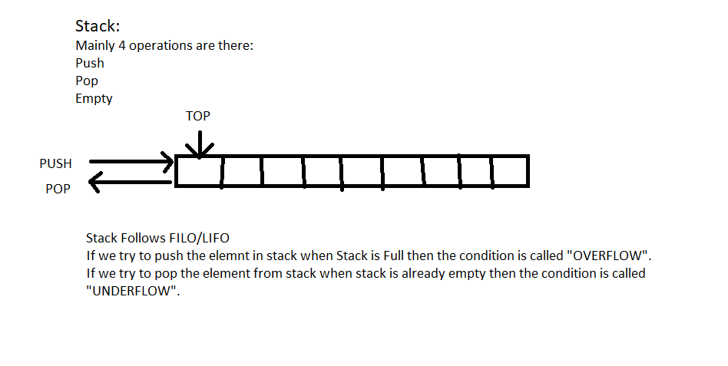

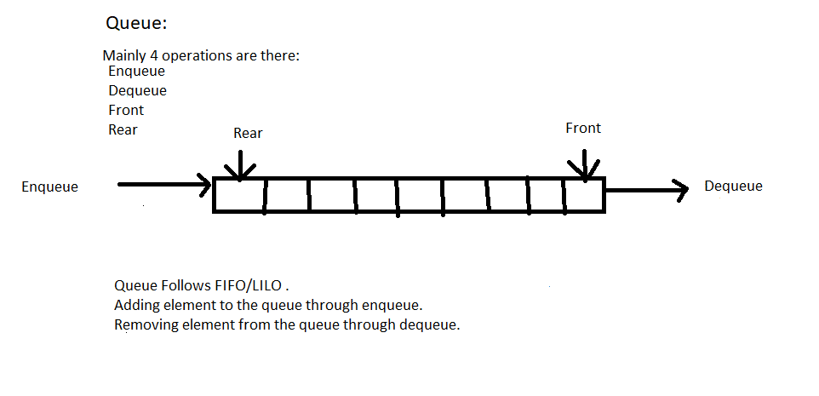

**Session 2**

1. take array of list apply linear search.

**package** my.searching;

**public** **class** linear {

**public** **static** **int** linear(**int**[] a,**int** k) {

**int** n=a.length;

**for**(**int** i=0;i<n;i++) {

**if** (a[i]==k) {

**return** i;

}

}

**return** -1;

}

**public** **static** **void** main(String[] args) {

**int** a[]= {1,2,3,4,5,6,7,8,9};

**int** k=6;

System.***out***.println("Element is found at position--"+*linear*(a,k));

}

}

OUTPUT:

Element is found at position—5.

2. Take array sorted apply binary search

**package** my.searching;

**public** **class** binary {

**public** **static** **int** binarySearch(**int** arr[] , **int** x) {

**int** n=arr.length;

**int** l=0,r=n-1;

**while**(l<=r) {

**int** m=l+(r-1)/2;

**if**(arr[m]==x) {

**return** m;

}

**if**(arr[m]<x) {

l=m+1;

}

**else** {

r=m-1;

}

}

**return** -1;

}

**public** **static** **void** main(String[] args) {

**int** a[]= {2,4,6,8,10,12,14,16};

**int** x=10;

**int** res=*binarySearch*(a,x);

**if** (res==-1) {

System.***out***.println("Element is not found");

}

**else** {

System.***out***.println("Element is found at position--"+res);

}

}

}

OUTPUT:

Element is found at position--4